# Task P7.1.4

## What do you think its purpose might be? (What do people want to know when they issue such a query?)

I think purpose of this query might be to get information about when customer has placed order according to date.

## Rewrite the query using proper JOIN syntax

SELECT CustFirstName, CustLastName, OrderDate FROM customers JOIN orders ON customers.CustomerID = orders.CustomerID ORDER BY CustLastName, CustFirstName, OrderDate DESC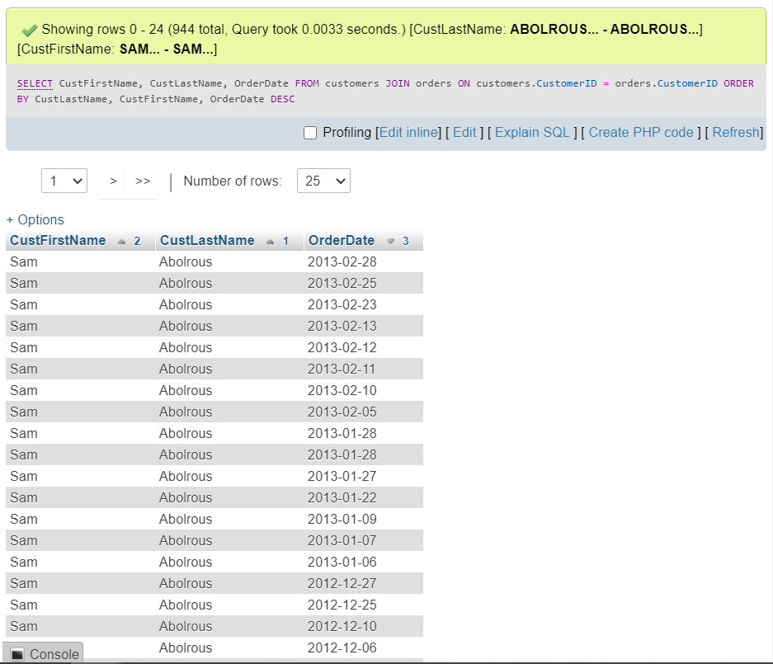

## Modify the query to include the one customer who doesn’t have an order.

SELECT Customers.CustFirstName, Customers.CustLastName, Orders.OrderDate FROM customers LEFT JOIN orders ON customers.CustomerID = orders.CustomerID

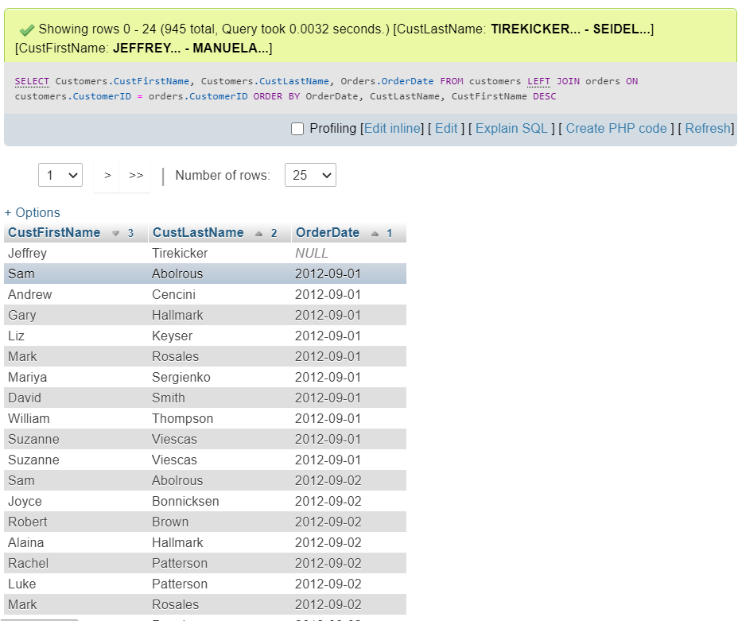

**\*ORDER BY is changed to show row with NULL values**

## Modify the query to include only the latest order of each customer.

SELECT Customers.CustFirstName, Customers.CustLastName, Orders.OrderDate FROM customers JOIN orders ON customers.CustomerID = orders.CustomerID WHERE Orders.OrderDate = (SELECT max(orders.OrderDate) from orders WHERE customers.CustomerID = orders.CustomerID) ORDER BY CustLastName, CustFirstName, OrderDate DESC